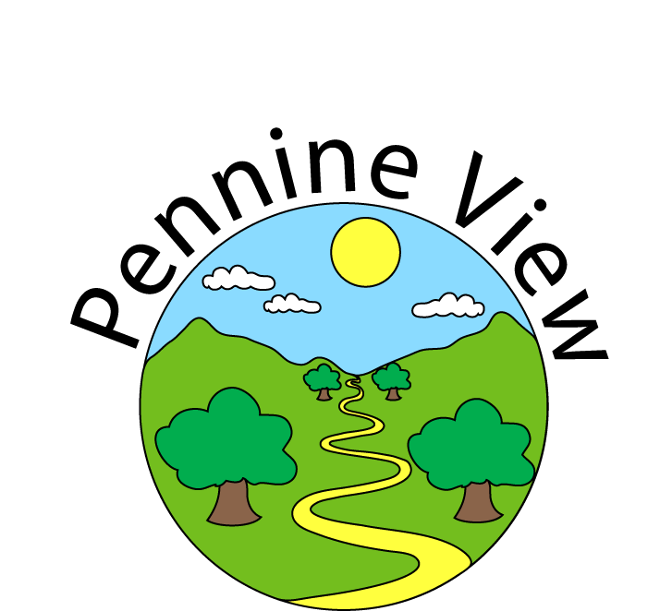

Curriculum Statement

|  |  |
| --- | --- |
| Date Published | December 2022 |
| Version | 3 |
| Approved Date |  |
| Review Cycle |  |
| Review Date |  |

An academy within:

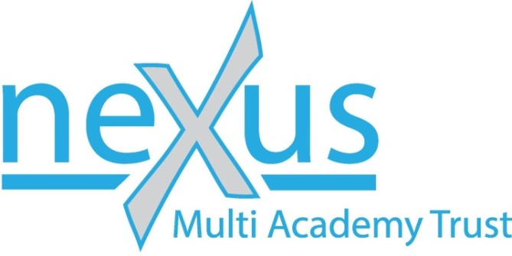

“Learning together; to be the best we can be”

# Context:

Pennine View School is a specialist provision for Key Stage 2 to Key Stage 4 children and young people with an Education Health and Care Plan. The predominant pupil needs across our school community are Moderate Learning Difficulties, Autistic Spectrum Disorder and Speech Language and Communication Needs. We are based in Doncaster, although we also have pupils from local neighbouring boroughs.

Our youngest pupils are just beginning to learn to read and write when they start at Pennine View and we support them to be able to achieve Entry Level certification in English and Maths Functional Skills by the time they leave Year 11.

Our Pennine View School curriculum is carefully developed to match the context of our school, to build on learning from home and previous mainstream education and to meet our aims and values:

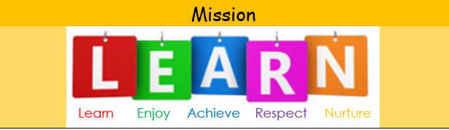

**Learn** - enabling all learners to increase their knowledge and understanding of the world

**Enjoy** - the right to receive a broad and balanced, high quality, personalised learning programme which generates enjoyment of learning

**Achieve** - encouraging all learners to be the best they can be

**Respect** – for one another and our environment

**Nurture** – implementing the highest levels of care and concern at all times

At Pennine View School we believe in:

* Providing exciting, rich and challenging learning opportunities
* Promoting independence and confidence
* Our learners having their own voice and making their own decisions
* Working together to ensure our children and their families are at the centre of everything we do

**Our Pennine View Curriculum**

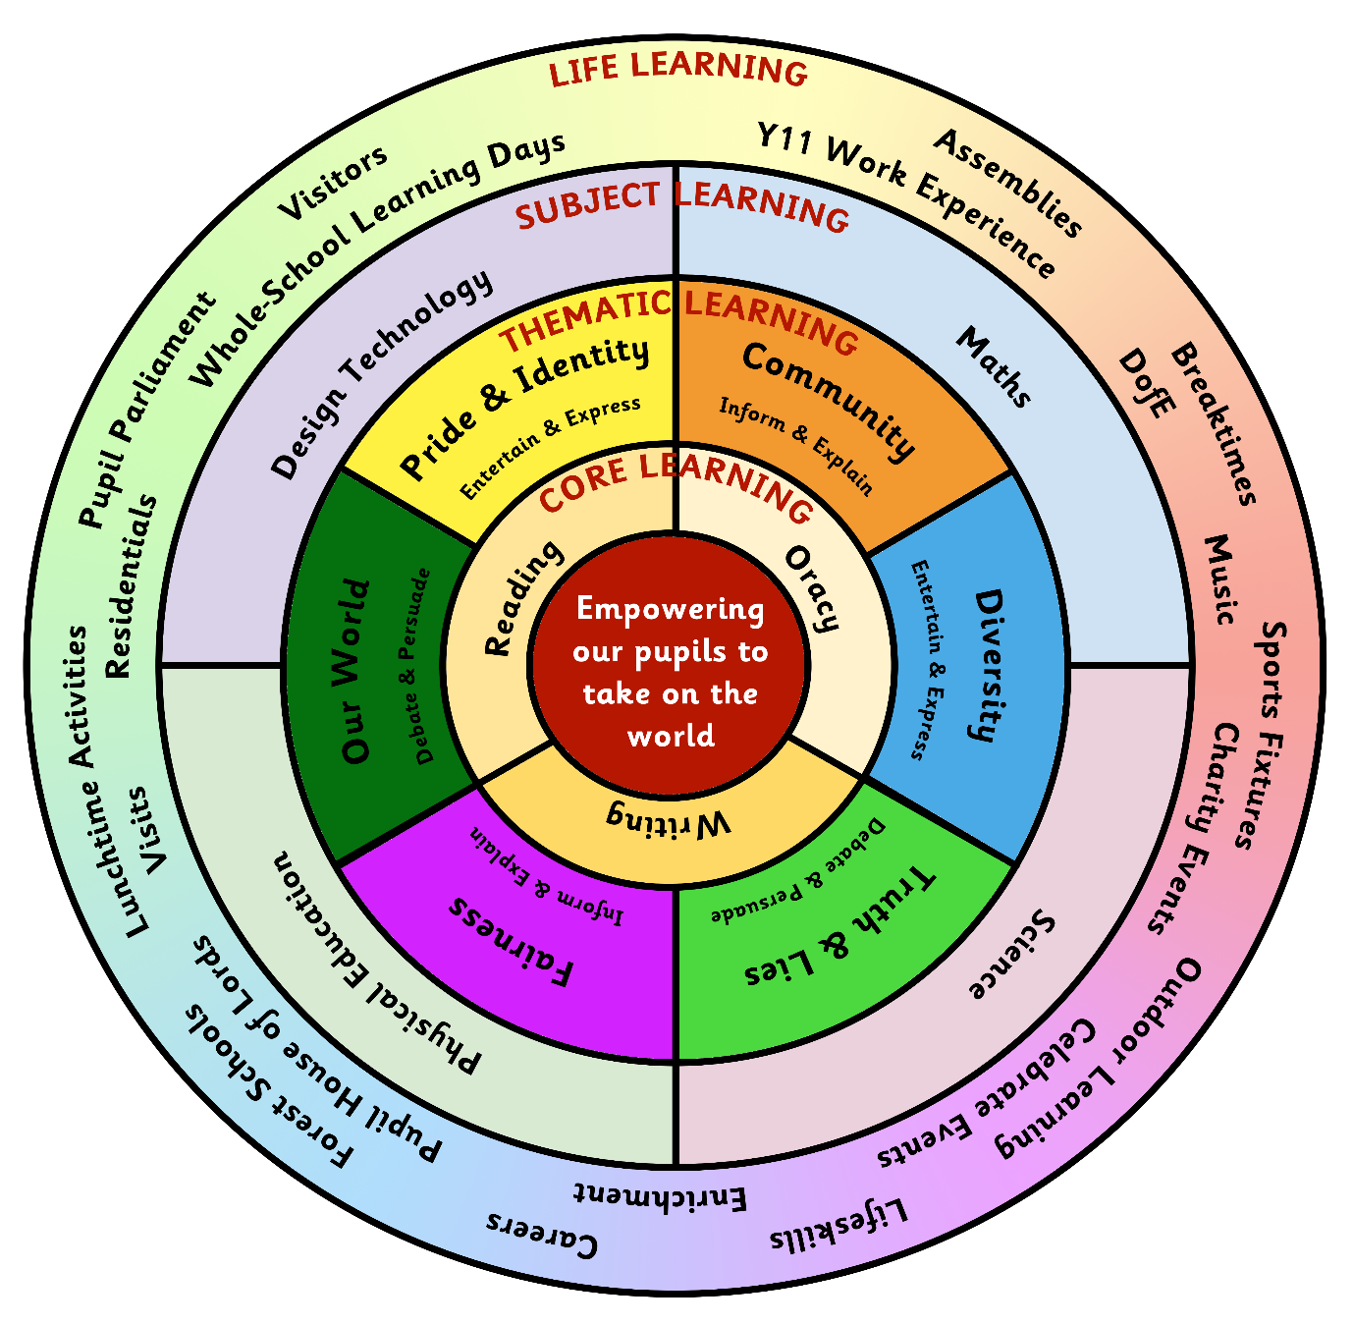

This is an illustration of our Pennine View School Curriculum. Our pupils are at the centre of everything we do and our vision – to empower our pupils to take on the world – is at the centre of our Pennine View Curriculum wheel. It is a broad and balanced curriculum that covers the statutory elements needed.

**Intent - What are we trying to achieve through our curriculum?**

‘One of the first steps on the civic journey is the education system. Education should help young people become active citizens once they understand their role within society and how they can go about improving it.’

*The Ties that Bind – House of Lords Report on Citizenship 2018.*

Our Pennine View Curriculum is designed to match the context of our school, to build on learning from home and previous mainstream education and to meet the needs of our pupils so that they can be recognised as global citizens. Our Pennine View Curriculum includes the statutory elements at a level appropriate to the stage and age of our pupils and it is centred around the essential knowledge and skills that our pupils need. It is a broad and rich programme of education which supports the development of functional academic learning, discovers talents and interests and secures positive communication and interaction skills, which we consider to be vital ingredients to be successful in later life.

Relationships are key at Pennine View; we ensure that pupils feel safe and happy, so that they are ready to **learn**, **enjoy** and **achieve**.

Our Curriculum empowers our pupils to take on the world because it:

* Is rooted in the real world
* Teaches pupils knowledge and skills to manage their own life and to develop positive relationships with others
* Is an introduction to local, national and global world issues
* Gives pupils a voice
* Shows pupils the world of work
* Challenges pupils views and extends their ideas
* Teaches pupils how to positively and respectfully challenge others views
* Gives pupils a wide range of experiences
* Helps pupils to believe that they can make a positive difference
* Helps pupils to embrace differences through accepting and celebrating our individuality

We also support pupils to be ready for tests so they can achieve accreditation to help them in their transition to Post 16 opportunities.

Our pupils are taught to embrace, enrich and celebrate their own beliefs and those of others, accepting these may be different, within the context of their school community, their local area and far beyond. Ultimately, we want our pupils to be well-informed so that they can be positive role models to influence those around them as they transition into adulthood.

Together, we can and will empower our pupils to take on the world.

**Implementation – How is our curriculum delivered?**

Our curriculum at Pennine View incorporates all parts of the school day; we recognise that these times are important opportunities for all our staff to teach our pupils the skills that they need to be successful when they leave Pennine View.

SMSC underpins our curriculum and permeates through our curriculum and together with equal opportunities is an integral feature of all aspects of the life of our school; of the formal curriculum, the informal curriculum and the ‘hidden’ curriculum; it is implicit in teaching strategies and approaches, the quality of relationships and the ethos of our school.

Teachers present subject matter clearly, promoting appropriate discussion about the subject matter being taught. They check pupils’ understanding systematically, identify misconceptions accurately and provide clear, direct feedback; they respond and adapt their teaching as necessary without unnecessarily elaborate or differentiated approaches.

Teachers create a stimulating learning environment that promotes focus pupil progress. The content, sequence of learning, resources and materials selected reflect our ambitious intentions for our Pennine View Curriculum. Our Pennine View Curriculum is coherently planned and is sequenced towards cumulatively sufficient knowledge and skills for future learning and employment. There are subject-specific progression models in place that focus on progression through the content to be learned.

Our Pennine View Curriculum is reviewed regularly in response to feedback from pupils and staff and in response to real life events.

**Pennine View Curriculum - Core Learning**

The core skill base to our curriculum is Oracy, Reading and Writing and these skills are explicitly taught throughout our curriculum and in discrete lessons, by class teachers, under the guidance of the subject leaders.

Our Oracy curriculum is developed from our work as a Voice 21 school. Oracy is the ability to articulate ideas, develop understanding and engage with others through spoken language, within and beyond school. Oracy is a powerful tool for learning; it empowers pupils to have a better understanding of themselves, others and the world around them. Through the development of Oracy skills at Pennine View, we also support pupils to be able to develop healthy, positive relationships and make and keep friends. Pupils learn to express themselves confidently which enables them to thrive and also navigate conflicts in their relationships in a positive and productive way.

Reading is an vital skill that all our pupils learn before they leave Pennine View. We read for pleasure, to develop our learning and as an essential lifeskill. Systematic Synthetic Phonics is used to enable pupils to decode and encode written language. We have interventions in place that overcome barriers to reading, whether neurological or physical. The school environment is reading-rich with a well-stocked library of high-quality texts and each classroom has a reading area. Pupils in Lower School have daily phonics lessons, as do pupils in Upper School who need further phonics teaching. Drop Everything and Read sessions take place daily where everyone can immerse themselves in the joy of reading.

Writing skills develop from oracy and reading. Our language-rich curriculum and environment develop vocabulary and grammatical skills with writing being taught and practiced daily. Written communication is another vital life-skill that all our pupils need for successful futures. All pupils write daily, with a skills focus, in a ‘daily write’. Writing also features as a communication and note-taking tool across the majority of lessons and as the outcome for English learning, where each week leads to a quality writing outcome with purpose and clarity of audience. English lessons each week develop from contextual learning, then exploration and vocabulary development through reading and drama, through to drafting and final writing outcomes.

**Pennine View Curriculum - Thematic Learning**

Every teacher in school takes some curriculum leadership responsibility as a ‘Curriculum Champion’. Staff work collaboratively in pairs with the support of the Curriculum Lead to lead an area of our Thematic Learning. Curriculum Champions plan a Whole School Learning Day at the beginning of each half term to engage pupils. Class teachers then plan and deliver a half term unit of work to their class on a topic linked to the Theme. Topics are carefully planned to ensure our pupils have access to a broad and balanced curriculum. Topics are enhanced by visits out of school and visitors in to school. Week 1 is focused on **Engage** activities, to hook the pupils in to learning. Teachers **Develop** pupils learning over the half term and in **Celebrate and Reflect** week pupils reflect on their learning journey and present their learning to an authentic audience.

Schemes Of Work in each subject area ensure that we have a broad and balanced Thematic Learning curriculum at Pennine View that reflects our vision and values to meet the needs of our pupils, both over the course of Year 3 to Year 11 and into adulthood. The Long Term Plan ensures sufficient coverage across each subject over time and supports our pupils to know more and remember more about our Thematic Learning, to broaden knowledge and provoke interest and excitement. It is continually reviewed to ensure it provides the best foundation for high quality teaching and learning in order to maximise our pupil’s life chances and economic well-being in adulthood.

Our Thematic Learning curriculum is planned around six whole school themes that incorporate key SMSC ideas that are relevant to life in the 21st century and is taught by class teachers, to their own class:

**Community – Essential Knowledge, Understanding and Skills**

Our pupils will be supported to become active and positive members of society and of their communities. The understanding of our lives, our communities and the UK social class system are imperative for social mobility. Only 6% of adults with Special Education Needs in the UK are in employment. Our pupils will be able to confront the issues of their daily lives and will have the tools to be able to combat these. Our pupils will develop qualities and experience successes which will enable them to be the best that they can be – responsible citizens who can take on the world!

**Diversity – Essential Knowledge, Understanding and Skills**

If our pupils are to be responsible global citizens then they need an understanding of their place in our world, how history has shaped modern society and how the rich diversity of our communities add to our shared cultural experiences. We are more special than one in a million: Each of us is 1 in 7.8 billion and our connections are what make us who we are.

**Truth and Lies – Essential Knowledge, Understanding and Skills**

We want our pupils to be honest and trustworthy citizens and, just as we need to teach them how to count or have a conversation, we need to teach them how to tell the truth, the importance of doing this and the implications of telling lies. We also need to teach them how to recognise truth and lies including in Social Media. Pupils need to understand that in the media, there are many examples of fake news. Pupils need to be able to identify fake stories and bias that affect current society and distort history. We want pupils to make their own informed choices based on accurate information.

**Fairness – Essential Knowledge, Understanding and Skills**

We want our pupils to be responsible, knowledgeable, well-informed citizens. This topic allows us to develop the concept of 'fairness': how we can consider other people and develop compassion in our pupils. This includes teaching about fair trade and the impact we can have through the choices we can make on people around the world, including children. Through teaching about fair trade, we can help our pupils to understand how our actions can affect other people, and support them to see themselves as people of the world.

**Our World – Essential Knowledge, Understanding and Skills**

A clean environment is vital to not only our own healthy living but the survival of all living things. Our environment is under threat and this is an urgent issue. Our pupils will leave Pennine View with an awareness and understanding of the effects of our actions upon the environment locally, nationally and globally.  We have one home, one planet, and it is the duty of all of us to ensure we do our best as caretakers of our world for the generations to come

**Pride and Identity – Essential Knowledge, Understanding and Skills**

For every young person to be prepared for life in modern Britain, it is vital that our curriculum reflects the full diversity of the world they live in. We celebrate individuality and diversity of gender identity and sexuality and encourage pride in our identities. LGBT+ inclusive teaching at Pennine View ensures that LGBT+ children and young people, and also those with LGBT+ families, see themselves reflected in what they learn. It encourages all our pupils to grow up and leave school with inclusive and accepting attitudes ready for adulthood.

**Pennine View Curriculum - Subject Learning**

Maths is taught 5 times each week by class teachers, under the guidance of the subject leader. Pupils follow the maths Scheme Of Work which ensures pupils are working at an appropriate level of challenge, through a Learn It, Use It, Apply It model. The ultimate goal in maths is for pupils to leave Pennine View with the key mathematical skills that support everyday life, feeling confident and proud of their achievements. Pupils need these core skills to live a fulfilling and successful life. Our maths curriculum is designed in such a way that all pupils are able to engage in, and find success with, mathematics.

Science teaches our pupils to develop curiosity, knowledge and the skills to question and investigate the world in which they live. Science lessons provide pupils with engaging and relevant first-hand practical experiences, aiming to stimulate and promote curiosity in a safe environment, where pupils feel confident to communicate and aren’t afraid to question and explore. Science is taught by class teachers at Key Stage 2, under the guidance of the subject leader. Year 7/8 pupils receive an hour of science lessons per week, being taught by the science specialist in the science laboratory. Upper School pupils receive between one hour and two and a half hours of science per week depending on the qualification route taken, delivered by the specialist science teacher in the science laboratory.

Design and Technology aims to inspire pupils through a broad range of practical experiences to create innovative designs which solve real and relevant problems within a variety of different contexts. Opportunities are provided for pupils to evaluate key events and individuals who have helped shape the world, showing the real impact of design and technology on the wider environment and helping to inspire pupils to become the next generation of innovators. DT is taught by the specialist DT teacher in the DT workshop. Key Stage 2 pupils have an hour a week of DT and Year 7/8 pupils have an hour and a half lesson each week.

PE is taught by the specialist PE teacher in the specialist Sports Hall or outside pitches. All pupils have a 90 minute lesson per week as part of a coherently planned sequence of lessons. Our intention is to develop a lifelong love of physical activity, sport and PE in all young people. We aim to help ensure a positive and healthy physical and mental outlook in the future and help young people to develop essential skills like leadership and teamwork.

**Pennine View Curriculum - Life Learning**

This aspect of our Pennine View Curriculum incorporates a wealth of activities, lessons and experiences which help to provide pupils with a rounded, culturally rich education through activities that enhance their learning.

Enrichment, a morning of activities for Upper School pupils, gives pupils opportunities to try new and varied activities that may not strictly fit into the curriculum, but that develops character, resilience, motivation and encourage them to pursue wider goals. It extends beyond the academic, technical or vocational and provides for pupils’ broader development, enabling them to develop and discover their interests and talents. It helps to teach life skills that benefit pupils beyond the classroom, and can develop an appreciation for cultural and community issues, teamwork and social responsibility. Pupils are able to make choices about the learning and activities they engage with and these include: dance, music, art, MFL, DT, enterprise, visits to local museums and art galleries, Commando Joe, multi-sports. Further opportunities are created depending on pupil feedback.

Lifeskills is taught by class teachers weekly. Lifeskills includes cooking skills and the specialist cooking room is therefore timetabled. At Year 7/8 classes learn Lifeskills every week, for a double lesson and use the cooking room for approximately 1/3 of the time. Year 9/10 pupils use the cooking room every week as part of their Lifeskills lessons, for a 60 – 90 minute lesson. Year 11 pupils spend a whole morning learning Lifeskills, which will include cooking. Our Key Stage 2 pupils usually learn cooking skills in the classroom but may use the cooking room occasionally. All pupils practice road safety skills and Lifeskills in context, out of school, including independent travel. Our Lifeskills Scheme of Work is progressive and covers a range of skills necessary to allow our pupils to live as independently as possible when they leave us and teachers structure their lessons through objective led planning from the Lifeskills Scheme of Work.

Outdoor Learning is active learning in the outdoors and is timetabled weekly for our youngest pupils, taught by a specialist teacher. In Outdoor Learning pupils learn through what they do, through what they encounter and through what they discover. Learning outside the classroom supports the development of healthy and active lifestyles by offering pupils opportunities for physical activity, freedom and movement, and promoting a sense of well-being.

Our Careers curriculum is delivered by class teachers in PSHE sessions, Whole School Learning Days and during the delivery of our Thematic Learning. To ensure access to appropriate and suitable materials for our pupils, we use material from My Skills, My Future, reinforced by the eight skills identified in the Skills Builder Universal Framework (Listening, Speaking, Creativity, Problem Solving, Staying Positive, Aiming High, Leadership and Teamwork). A fundamental aspect of our curriculum is that we want our pupils to experience and embrace opportunities on visits to enrich their curriculum offer and also the importance of visitors coming in and developing their learning opportunities and experiences. We want our pupils to have meaningful encounters with employers and employees.

Music is delivered mostly by outside providers such as DARTS at Key Stage 2 and is taught through Enrichment opportunities at Upper School. Music appreciation, creation and performance also takes place through our Thematic Learning. The creative arts have such a significant impact on all our lives and are fundamentally part of who we are. It is therefore vital that pupils develop the skills to engage with music and follow their passions.

DofE and Forest Schools are part of our curriculum for Robin class at The Bridge and are led by qualified practitioners. Both courses are practical in nature and create opportunities to learn beyond the confines of a classroom. The aims of both courses fit well with our Pennine View Curriculum aims; youth without limits, regardless of background, culture or ability, bringing communities together, sharing skills and creating opportunities.

Our Life Learning curriculum also encompasses all the other opportunities that we plan for our pupils, both in and out of school and incorporates all parts of the school day.

**Class Groups**

Pupils are grouped in mixed age classes and move classes depending on age:

* Year 3-5 (Barn Owl)
* Year 5-6 (Tawny Owl)
* Year 7/8 (Eagle, Falcon, Harrier, Merlin)
* Year 9/10 (Osprey, Kestrel, Red Kite)
* Year 11 (Robin, Kingfisher)

Year 3 – Year 8 pupils are part of Lower School, Year 9 – Year 11 pupils are part of Upper School. Robin class are taught at our Nexus off-site provision, The Bridge, all other classes are taught at our Conisbrough site. Class sizes are usually 12 pupils with one teacher and two Teaching Assistants.

**Our Teaching Approach**

Our approach to teaching is matched to the learning needs of pupils as they grow and develop.

At the **EXPERIENCE** level, pupils encounter learning in a range of contexts and are given opportunities to observe, explore and play. This stage is about experiencing new concepts and ideas through play and exploration. It is about being creative and curious. It is about encouraging pupils to ask questions. We encourage pupils to take themselves on their own journeys of discovery. Role play, continuous provision and creative activities are the vehicles for learning. Learning is implicitly linked to the whole-school themes through careful selection of resources and experiences. We take every opportunity to support learning in real life situations through visits and visitors. Staff are enablers and facilitators of learning at this stage through questioning, and modelling awe and wonder at the world. This is the foundation for empowering our pupils to take on the world.

At the **EXPRESS** level, pupils encounter learning in a range of contexts and are supported to be able to develop and express their own opinions across the curriculum. This stage is about experimenting with concepts and ideas. It is about being courageous and innovative. It is about encouraging pupils to find their own voice and develop their identity. We encourage pupils to respect and accept others’ opinions and individuality. Drama, communities of inquiry and immersive experiences are the vehicles for learning. We take every opportunity to extend learning in real life situations through visits and visitors. Staff are facilitators of pupil-led learning at this stage through challenge and support, and creating a safe environment for every pupil to express themselves. This is the platform for empowering our pupils to take on the world.

At the **ASSERT** level, pupils build on previous learning in a range of contexts, explicitly learning about a range of local and global issues and are supported to be able to assert and justify their own opinions across the curriculum. This stage is about flexibility and refinement of concepts and ideas, with pupils being able to debate and reflect, ready to change their minds or hold their ground. It is about being confident and self-aware. It is about encouraging pupils to have conviction in their own views and the voice to communicate clearly. We encourage pupils to respect and accept others’ opinions and individuality but understand how to respectfully disagree. Drama, debate, communities of inquiry and real experiences are the vehicles for learning. We take every opportunity to extend learning in real life situations through visits and visitors and the media. Staff are facilitators of pupil-led learning at this stage, providing opportunities for pupils to become experts in concepts, refine their ideas and demonstrate clear understanding of the knowledge and skills they have learned. Our pupils are now empowered to take on the world.

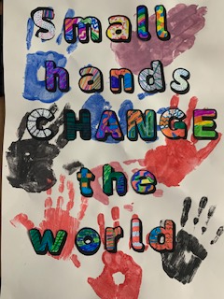

**Impact – What difference does our curriculum make?**

Our pupils will:

* Be able to communicate with others
* Learn skills of team work
* Be questioning
* Show resilience
* Learn from mistakes
* Be creative in their thinking
* Think through consequences before making decisions
* Be motivated and approach tasks in a positive way
* Have high aspirations
* Believe in themselves

Analysis of assessment, on a termly basis, evidences the progress our pupils are making in the **Core Learning** areas of reading, writing and Oracy and in the **Subject Learning** area of maths. Science, PE and DT leads also track pupil progress in their **Subject Learning** areas.

Impact is also evidenced through:

* Dojo – class and school stories
* Pupil work books
* Displays
* Celebrate Events at the end of a unit of work – a presentation of learning to an authentic audience
* Reflection activities at the end of a unit of work – pupils are encouraged to consider what they have learned and enjoyed
* Assessment data for reading, writing, maths
* Feedback from pupils, families and staff
* Annual Reviews and End of Year Reports
* External accreditation at Year 11 (English, maths, science)
* Successful transition to Post 16

By the end of Year 11, our pupils have developed their skills, confidence and self-esteem so that they can be successful in their next stages of education and in their adult life. Our pupils have developed healthy, positive relationships and know how to make and keep friends. Our pupils are able to express themselves confidently which enables them to thrive and also navigate conflicts in their relationships in a positive and productive way.

**Together, we can and will empower our pupils to take on the world.**